**SOFTWARE VERIFICATION, VALIDATION AND TESTING**

TESTING DOCUMENTATION

PROJECT NAME

Prepared by:

**Ajdin Hukić**

Proposed to:

**Samed Jukić, Assist. Prof. Dr.**

**Aldin Kovačević, Teaching Assistant**

16.01.2023.

TABLE OF CONTENTS

Contents

1. Introduction 3

1.1. About the Project 3

1.2. Project Functionalities and Screenshots 3

3

2. Test Plan 4

2.1. Scope 4

2.2. Testing Environment and Tools. 4

3. Test Execution 5

3.1. Homepage 5

3.1. Register 7

3.1. Trello authorization and project management 8

9. Conclusion 16

9.1. Testing Summary 16

9.2. Final Thoughts 16

# 1. Introduction

## 1.1. About the Project

This project is about testing main homepage of trello.com and their registration, authorization. Main testing was about testing Trello tool for project management.

## 1.2. Project Functionalities and Screenshots

Main things tested on main page are video playback and slide shows

# 

Registration feature uses random email generation while authorization uses predefined user account login data.

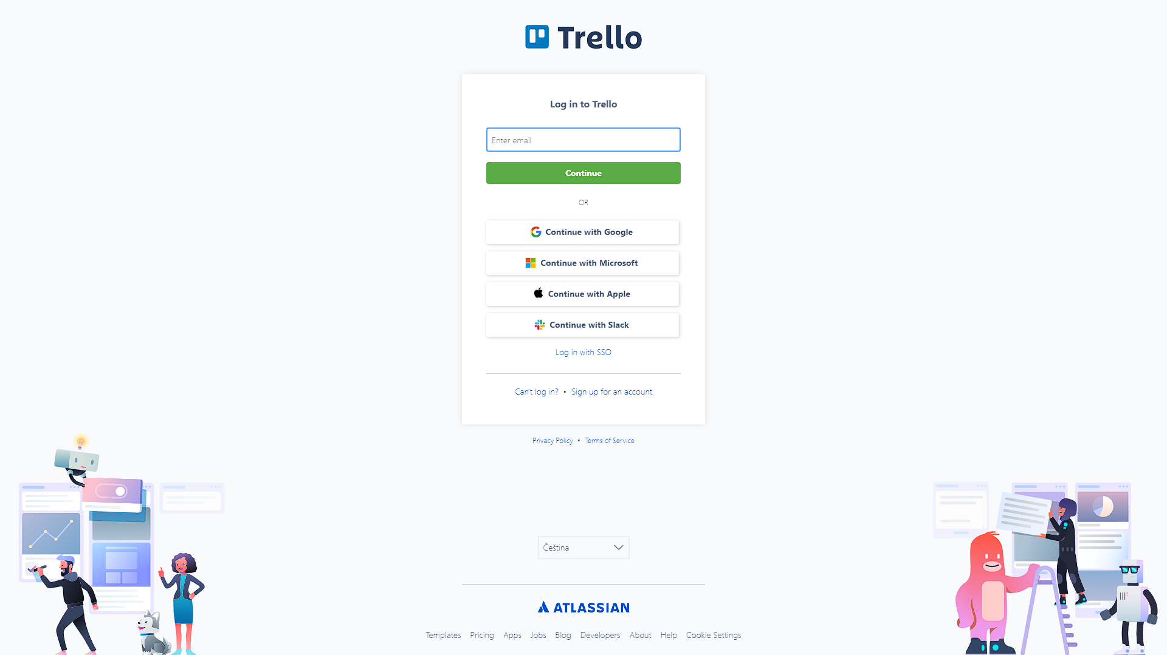

So main feature of this testing is testing of Trello board for project management.

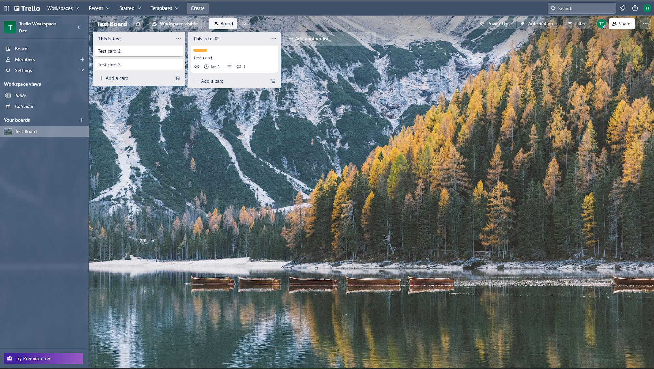

# 2. Test Plan

## 2.1. Scope

Trello.com is really complex website with lots of hyperlinks leading to different pages at least the non-authorized page, while testing of board is more detailed it is not full testing as I do not have premium account for all features and some features are really complex to be tested in some reasonable time.

## 2.2. Testing Environment and Tools.

I used Java with selenium framework. It was tested with chrome webdriver.

# 3. Test Execution

## 3.1. Homepage

Users want to be able to visit the home page, and get a quick glance at the most important features it has to offer.

|  |  |  |  |  |
| --- | --- | --- | --- | --- |
| **Test Name:** Header test | | | | |
| **Description:**  Check if first big header is loaded | | | | |
| **Pre-condition(s):** | | | | |
| **Test Steps:**  1. Get text from header  2. Test if text is equal to expected output | **Test Data:** | **Expected Result:**  “Trello brings all your tasks, teammates, and tools together” | **Actual Result:**  “Trello brings all your tasks, teammates, and tools together” | **Status:**  PASS |
| **Notes:** | | | | |
| **Image of code:** | | | | |

|  |  |  |  |  |
| --- | --- | --- | --- | --- |
| **Test Name:** Video test | | | | |
| **Description:**  Check if hyperlink watch video loads modal for video and test if it playbacks and stops | | | | |
| **Pre-condition(s):** | | | | |
| **Test Steps:**  1. Press watch video button  2. Wait for modal of video to load  3. Press play button  4. Wait for video to start  5. Wait for video to get to 0:10 mark  6. Press stop button  7. Check if video is stopped on 0:10  8. Press close button of modal | **Test Data:** | **Expected Result:**  Video starts at 0:00, plays trough 0:10 mark, and then on stop execute it stops there | **Actual Result:**  Video plays and stops fine | **Status:**  PASS |
| **Notes:** JavaScript Executor was used for pressing play, stop button due to video modal being 3rd party service | | | | |
| **Image of code:** | | | | |

|  |  |  |  |  |
| --- | --- | --- | --- | --- |
| **Test Name:** Slideshow | | | | |
| **Description:**  Checks if slideshow buttons work on desktop and if its mobile version check dot buttons of slideshow | | | | |
| **Pre-condition(s):** | | | | |
| **Test Steps:**  1. Checks if desktop button is displayed  2. If its displayed press it, if not press mobile button  3. Check if slide(image) is displayed or not  4. Repeated previous steps but for different slide images | **Test Data:** | **Expected Result:**  Aria-hidden attribute of element changes to false or true | **Actual Result:**  Attribute changes fine according to button pressed | **Status:**  PASS |
| **Notes:** | | | | |
| **Image of code:** | | | | |

|  |  |  |  |  |
| --- | --- | --- | --- | --- |
| **Test Name:** Slider | | | | |
| **Description:**  Checks if template section of horizontal slider with images is working | | | | |
| **Pre-condition(s):** | | | | |
| **Test Steps:**  1. Press and drag whole section of slider.  2. Check if css property of margin-left is changed accordingly  3. Then do same but in reverse  4. And check if margin-left is back to previous value | **Test Data:** | **Expected Result:**  Margin-left changes to corresponding values | **Actual Result:**  Margin-left changes to exact values | **Status:**  PASS |
| **Notes:** | | | | |
| **Image of code:** | | | | |

## 3.1. Register

Users want to be able to register.

|  |  |  |  |  |
| --- | --- | --- | --- | --- |
| **Test Name:** Header test | | | | |
| **Description:**  Check if first big header is loaded | | | | |
| **Pre-condition(s):** | | | | |
| **Test Steps:**  1. Get text from header  2. Test if text is equal to expected output | **Test Data:** | **Expected Result:**  "Sign up for your account" | **Actual Result:**  "Sign up for your account" | **Status:**  PASS |
| **Notes:** | | | | |
| **Image of code:** | | | | |

|  |  |  |  |  |
| --- | --- | --- | --- | --- |
| **Test Name:** Register test | | | | |
| **Description:**  Check if header is loaded and we are on right page | | | | |
| **Pre-condition(s):** | | | | |
| **Test Steps:**  1. Input random email generated by method getRandomMail()  2. Click submit button  3. 10 second timeout is given for manual input of google captcha  4. Check if displayed text is one for verification mail is sent  5. Press resend verification mail  6. Check if given text of toastr is one for resend verification | **Test Data:**  Random mail is generated | **Expected Result:**  Text "To complete setup and log in, click the verification link in the email we’ve sent to" is displayed and text of toastr is "We've sent you an email!" displayed after button is pressed | **Actual Result:**  Both texts are displayed | **Status:**  PASS |
| **Notes:** | | | | |
| **Image of code:** | | | | |

## 3.1. Trello authorization and project management

Users want to be login and make a new board for project management, after that user wants be able to use that board.

|  |  |  |  |  |
| --- | --- | --- | --- | --- |
| **Test Name:** Header test | | | | |
| **Description:**  Check if header is loaded and we are on right page | | | | |
| **Pre-condition(s):** | | | | |
| **Test Steps:**  1. Get text from header  2. Test if text is equal to expected output | **Test Data:** | **Expected Result:**  "Sign up for your account" | **Actual Result:**  "Sign up for your account" | **Status:**  PASS |
| **Notes:** | | | | |
| **Image of code:** | | | | |

|  |  |  |  |  |
| --- | --- | --- | --- | --- |
| **Test Name:** Header test | | | | |
| **Description:**  Check if header is loaded and we are on right page | | | | |
| **Pre-condition(s):** | | | | |
| **Test Steps:**  1. Input of predefined email is sent  2. Continue button press  3. Input of predefined password is typed  4. Login button press | **Test Data:**  Email - [trellotestingajdin@gmail.com](mailto:trellotestingajdin@gmail.com)  Password - Ajdin123 | **Expected Result:**  After login authorized page is shown | **Actual Result:**  Page is loaded | **Status:**  PASS |
| **Notes:** | | | | |
| **Image of code:** | | | | |

|  |  |  |  |  |
| --- | --- | --- | --- | --- |
| **Test Name:** New board | | | | |
| **Description:**  Test creates new project management board | | | | |
| **Pre-condition(s):** Needs to be authorized which is done by test before | | | | |
| **Test Steps:**  1. Click on Create  2. Click on new board  3. Board title is typed  4. Click on create board | **Test Data:** | **Expected Result:**  New board is created and opened | **Actual Result:**  New board is displayed on page | **Status:**  PASS |
| **Notes:** | | | | |
| **Image of code:** | | | | |

|  |  |  |  |  |
| --- | --- | --- | --- | --- |
| **Test Name:** New swimlanes | | | | |
| **Description:**  Test creates new swim lane in board | | | | |
| **Pre-condition(s):** Needs to be authorized and board needs to be opened which is done by tests before | | | | |
| **Test Steps:**  1. Click add another list  2. List(swim lane) name is typed  3. Click add list  4. Repeat steps for one more swim lane | **Test Data:** | **Expected Result:**  2 swim lanes are created | **Actual Result:**  2 swim lanes are displayed | **Status:**  PASS |
| **Notes:** Assertion of text This is test can fail because trello sometimes gives template version of new board in 10% cases that happens, I am not sure what causes it, it looks like trello sided issue | | | | |
| **Image of code:** | | | | |

|  |  |  |  |  |
| --- | --- | --- | --- | --- |
| **Test Name:** New cards | | | | |
| **Description:**  Test creates three new cards in first list(swim lane) | | | | |
| **Pre-condition(s):** Needs to be authorized and board needs to be opened, and list needs to be created which is done by tests before | | | | |
| **Test Steps:**  1. Click Add Card if displayed  2. Type card name  3. Click add card  4. Repeat steps for two more cards | **Test Data:** | **Expected Result:**  I cannot test(or I do not know) for result as name of card is not html element rather just regular text without element, so I get error that text is not available from it | **Actual Result:**  <- | **Status:**  PASS |
| **Notes:** | | | | |
| **Image of code:** | | | | |

|  |  |  |  |  |
| --- | --- | --- | --- | --- |
| **Test Name:** Enter card | | | | |
| **Description:**  Enters newly created card | | | | |
| **Pre-condition(s):** Needs to be authorized and board needs to be opened, and list and card needs to be created, which is done by tests before | | | | |
| **Test Steps:**  1. Click on card name  2. Check if card opens | **Test Data:** | **Expected Result:**  Card opens | **Actual Result:**  Card modal opens | **Status:**  PASS |
| **Notes:** | | | | |
| **Image of code:** | | | | |

|  |  |  |  |  |
| --- | --- | --- | --- | --- |
| **Test Name:** Change description | | | | |
| **Description:**  This test adds description to card | | | | |
| **Pre-condition(s):** Needs to be authorized and board needs to be opened, and list and card needs to be created and entered, which is done by tests before | | | | |
| **Test Steps:**  1. Click on description text area  2. Type in description  3. Click on save button  4. Verify that it is typed | **Test Data:** | **Expected Result:**  Text of “This is test description”  should appear for description | **Actual Result:**  Text appears for description | **Status:**  PASS |
| **Notes:** Sometimes text area is already clicked so we need check for that | | | | |
| **Image of code:** | | | | |

|  |  |  |  |  |
| --- | --- | --- | --- | --- |
| **Test Name:** Make a comment | | | | |
| **Description:**  This test adds comment to card | | | | |
| **Pre-condition(s):** Needs to be authorized and board needs to be opened, and list and card needs to be created and entered, which is done by tests before | | | | |
| **Test Steps:**  1. Type comment into text area  2. Check if comment is written | **Test Data:** | **Expected Result:**  Comment should be written as “This is test comment yaay” | **Actual Result:**  Comment is shown under comment section | **Status:**  PASS |
| **Notes:** | | | | |
| **Image of code:** | | | | |

|  |  |  |  |  |
| --- | --- | --- | --- | --- |
| **Test Name:** Add label | | | | |
| **Description:**  This test adds orange label to card | | | | |
| **Pre-condition(s):** Needs to be authorized and board needs to be opened, and list and card needs to be created and entered, which is done by tests before | | | | |
| **Test Steps:**  1. Click on label button  2. Click orange label  3. Click on exit button for label selection  4. Check if label is displayed | **Test Data:** | **Expected Result:**  Label should be shown on card | **Actual Result:**  Label is shown | **Status:**  PASS |
| **Notes:** | | | | |
| **Image of code:** | | | | |

|  |  |  |  |  |
| --- | --- | --- | --- | --- |
| **Test Name:** Add due | | | | |
| **Description:**  This test adds due date to card | | | | |
| **Pre-condition(s):** Needs to be authorized and board needs to be opened, and list and card needs to be created and entered, which is done by tests before | | | | |
| **Test Steps:**  1. Click on date button  2. Click on last day  3. Click on save button  4. Check if due date is displayed | **Test Data:** | **Expected Result:**  Due date should be displayed | **Actual Result:**  Due date is shown | **Status:**  PASS |
| **Notes:** | | | | |
| **Image of code:** | | | | |

|  |  |  |  |  |
| --- | --- | --- | --- | --- |
| **Test Name:** Exit card | | | | |
| **Description:**  Exits newly created card | | | | |
| **Pre-condition(s):** Needs to be authorized and board needs to be opened, and list and card needs to be created, which is done by tests before | | | | |
| **Test Steps:**  1. Click on exit button | **Test Data:** | **Expected Result:**  Card closes(not testable due card modal being destroyed) | **Actual Result:**  Card modal is closed | **Status:**  PASS |
| **Notes:** | | | | |
| **Image of code:** | | | | |

|  |  |  |  |  |
| --- | --- | --- | --- | --- |
| **Test Name:** Move card | | | | |
| **Description:**  Moves modified card from one swim lane to another | | | | |
| **Pre-condition(s):** Needs to be authorized and board needs to be opened, and list and card needs to be created, which is done by tests before | | | | |
| **Test Steps:**  1. Click on card  2. Drag it into element of other swim lane | **Test Data:** | **Expected Result:**  Card is in other swim lane | **Actual Result:**  Card is displayed in other swim lane | **Status:**  PASS |
| **Notes:** | | | | |
| **Image of code:** | | | | |

|  |  |  |  |  |
| --- | --- | --- | --- | --- |
| **Test Name:** Move card | | | | |
| **Description:**  Moves modified card from one swim lane to another | | | | |
| **Pre-condition(s):** Needs to be authorized and board needs to be opened, and list and card needs to be created, which is done by tests before | | | | |
| **Test Steps:**  1. Click on card  2. Drag it into element of other swim lane | **Test Data:** | **Expected Result:**  Card is in other swim lane | **Actual Result:**  Card is displayed in other swim lane | **Status:**  PASS |
| **Notes:** | | | | |
| **Image of code:** | | | | |

|  |  |  |  |  |
| --- | --- | --- | --- | --- |
| **Test Name:** Remove board | | | | |
| **Description:**  Removes created board | | | | |
| **Pre-condition(s):** Needs to be authorized and board needs to be opened. And this should be only board on account, because it closes one from top. | | | | |
| **Test Steps:**  1. Click on expand  2. Hover on boards  3. Press 3 dots icon  4. Click close  5. Click close for confirmation  6. Check if board closed box appears | **Test Data:** | **Expected Result:**  Closed board box is shown | **Actual Result:**  Closed board box displays | **Status:**  PASS |
| **Notes:** If not only board on account will close another board and closed board won’t appear | | | | |
| **Image of code:** | | | | |

# 9. Conclusion

## 9.1. Testing Summary

Provide a summary of all your executed tests. Something like this would be alright:

|  |  |  |  |
| --- | --- | --- | --- |
| **Testing Tool** | **Total Tests** | **Passed Tests** | **Failed Tests** |
| Java with selenium  Chrome web driver | 20 | 20 | 0 |

If there are failing tests, provide a list of their names. Ideally, you can also create bookmarks in the document and make links to those failing test cases.

## 9.2. Final Thoughts

There are some things which are weird like new lists (swim lanes) appearing with some predefined template, even if I do not chose any template for my new board so test gives assertion failed in 10% of cases, which I do not control. But anyways I was not testing templates are they too much complex to be tested in reasonable time. Site overall as company it is huge, so testing everything is hard. But I focused on some of main features. And additionally a lot of features are premium.